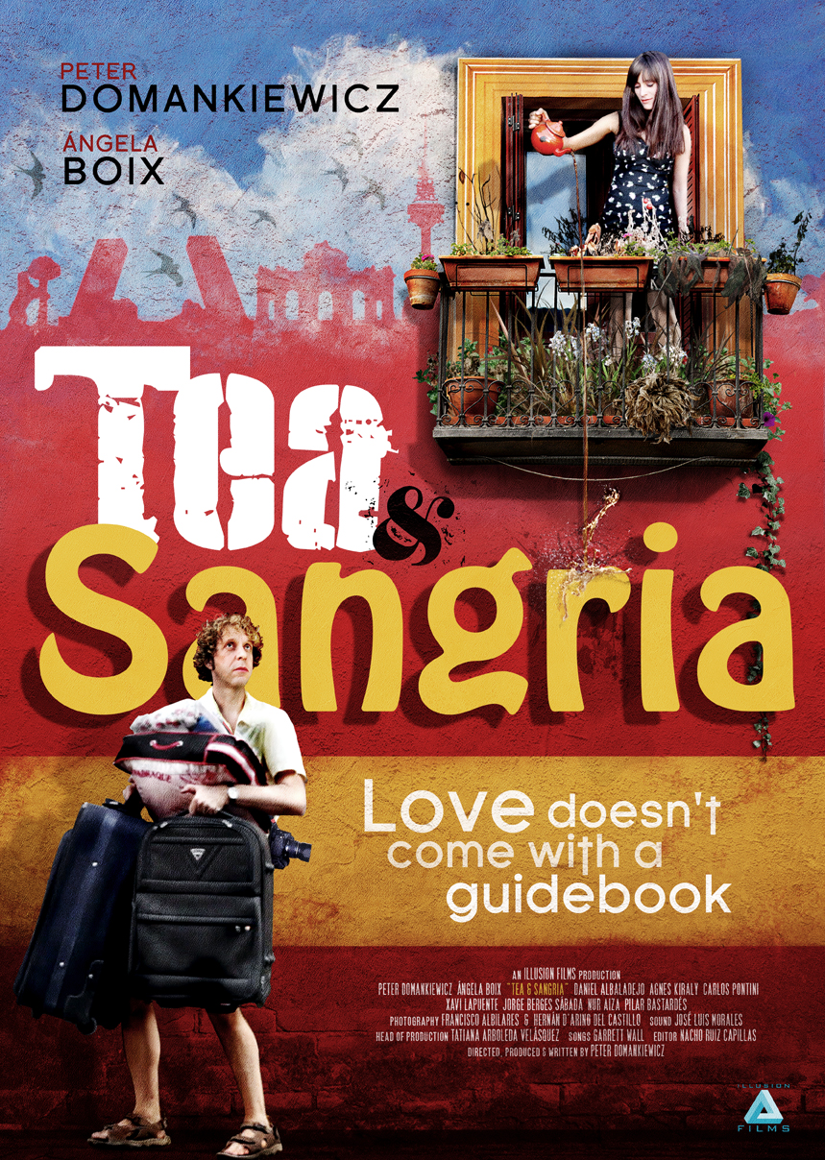

Running Time 110 mins

UK Release Date 24th April 2015

BBFC Cert 15

UK Distribution Miracle Communications/Illusion Films

Press Information Lisa Richards
lisa@lisarichardspr.net, 07798 876 352
Official site http://www.teaandsangriamovie.com/

TEA & SANGRIA
Love doesn’t come with a guidebook
Written and Directed by
Peter Domankiewicz
Starring
Peter Domankiewicz, Angela Boix, Pilar Bastardes, Carlos Pontini, Daniel Albaladejo, Nur Aiza, Xavi Lapuente, Jorge Berges Sabada, Agnes Kiraly

Jilted in Madrid, a bewildered Englishman must learn to live and love again - the Spanish way.
Following an intense holiday romance David, a love-struck Englishman, arrives in Madrid having abandoned everything back home, to live with his Spanish girlfriend Marisa. But, instead of ‘Happily Ever After’, their relationship soon turns sour and David finds himself stranded in a foreign city where he barely speaks the language, has no job and nowhere to live. Instead of quietly escaping back home, nursing his broken heart, he decides to immerse himself in Latin life and is forced to come to terms with what life in Spain is really like when the holiday is over. With the help of some lively locals David begins to get to grips with the clashes between Mars and Venus and English and Spanish cultures. Life in Madrid takes its fair share of outrageous and bizarre turns as he begins to discover that, in order to love a Spanish woman, you first have to learn to love Spain… And that can get very complicated.
Written, produced and directed by Peter Domankiewicz (who also stars as David) Tea & Sangria is inspired by his own experiences of moving to the Spanish capital. The end result – shaped with the help of the Goya-winning editor of Alejandro Amenábar’s The Others, Nacho Ruiz Capillas, is a charming and funny alternative romantic comedy that reveals what can sometimes happen when real life interferes with real love.
Filmed entirely on location in Madrid, Tea & Sangria reveals the true heartbeat of a city beyond the obvious tourist haunts - an Englishman’s rough-around-the edges love letter to the Spanish capital and those who live and love there.

About the filmmakers
PETER DOMANKIEWICZ – DIRECTOR/WRITER/PRODUCER/PROTAGONIST
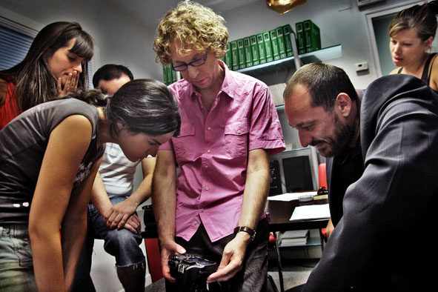
With a Polish father, English mother, French relatives and many years in Spain, Peter Domankiewicz can justly claim to be a European filmmaker. But it was not ever thus. It has been a long and winding road that has led through singing and songwriting, playing in a band, being a radio presenter, doing experimental film, commercial video and award-winning independent theatre before finally getting his first TV commission in 1995 – a poetic short created from real home movies, MEMOIRS OF AN IMAGINARY CHILDHOOD, which went on to screen in many international festivals and tour with FARGO.
This was followed in 1996 by his first conventional narrative work, a fantasy folk tale, drawn from the Brothers Grimm, THE GIFT OF DEATH. Never one for doing things the easy way, it was an ambitiously long fantasy ‘short’ at 30 minutes, premiering at Encounters in Bristol and then shown around the UK with SHINE and screened on television. This led to his first TV drama commission, SUMMER OF LOVE, starring Jenny Agutter and Laura Fraser, which he co-wrote, directed and produced for ITV – a combination of roles that rarely happens in television and never with a newcomer. It was developed into a series, but never made.
Over the ensuing years he produced television drama, commercials and short films for cinema, as well as directing another short, A QUIET NIGHT IN before starting to develop feature film projects. Then life took him to Madrid and he stayed seven years. There he developed a series of feature film projects with different producers, including an adaptation of a J.G. Ballard novel. But, as is the way with most film projects, these did not come to fruition. Meanwhile, he stumbled into studying acting, quite literally by accident, and decided to see where it led.
He first wrote his story about an Englishman who gives up everything to live with his Spanish girlfriend in Madrid, only for the relationship to turn sour, back in 2009, inspired by his own experiences of moving to the Spanish capital. Peter touted the completed script to Spain’s top producers – “Everybody said they liked it, everybody said they thought it was funny – nobody went for it” – so Peter decided that it had now been too long since he last directed and took matters into his own hands. “I just said, that’s it, I’m making it myself.”
He formulated a reckless and, frankly, absurd plan to simply make the film on a miniscule budget, taking on the roles of writer, director and producer and working with new acting talent and a small, fresh-faced crew. Ransacking his savings to purchase equipment, shooting permits and food to bribe his Spanish actor and filmmaker friends into helping him, he quickly put the wheels in motion.
Who, though, to play the lead role of the broken-hearted Englishman learning to find his way in a foreign city? It screamed out for a Simon Pegg-type, but with no cash and acting classes recently under his belt, he saw no choice but to cast himself.
Working as his own director was no sweat, he explains. The problem was juggling everything else as well. “What is hard is literally, between one shot and the other, having to run out of the building where you are, run down the street to a cash point, take out €200 from your account, run back, give it to somebody and tell them go somewhere, do something, or pay somebody, and then get back into character and step back in front of the camera and carry on the scene. That is enough to push you into a nervous breakdown.”
The result was near disaster. The unorthodox working methods necessitated by the microscopic budget – a “flexi-crew” that often didn’t consist of more than five or six people; handheld shooting on a digital SLR camera; the minimum of takes; moving between locations by Metro – didn’t always sit well with some of the film school grads who’d originally signed up and been trained to make movies in a particular way. “The first two weeks, we lost every important member of the crew,” he remembers. “Some of them two or three times over. It was the most horrendous shooting period I’ve ever had.”
He almost gave up, he admits. The lowest moment came sitting outside an Indian restaurant on Lavapiés street at 1am after a particularly tough day’s filming. “I can remember just sitting there weeping and eating Indian food with people walking by paying no attention to me. All on my own. With the whole thing now on my shoulders. Just actually thinking Peter, you HAVE bitten off more than you can chew. You cannot make a film with almost no money at all and a bunch of relatively inexperienced actors and crew and really no good reason why they should even work for you for nothing.”
Gradually, though, with the help of actress Ángela Boix, who plays his on-off girlfriend Marisa in the film, and Colombian production manager Tatiana Arboleda, he assembled around him the people he needed to move forward.
If anything, the small-scale shoot made filming in the middle of Madrid even easier. No one batted an eyelid as they shot a scene of him carrying a passed-out Boix through busy Puerta del Sol: “I think the take in the film is the second or the third and still everybody’s looking at us. If you watch the entire crowd, they’re looking at us like she’s really passed out and not looking at the bloke with the camera. Because he could just be somebody in the crowd who’s pointing their camera at it. […] Very rarely did we have the issue that members of the public interfered.”
The end result was shaped with the help of the Goya-winning editor of Alejandro Amenábar’s The Others, Nacho Ruiz Capillas, who signed up simply because he liked what he saw.
The plot might feature its fair share of outrageous turns – though he says some of the more bizarre moments were true – but it’s often spot on when it comes to picking apart British and Spanish cultural differences: the difficulties of explaining vegetarianism to a Spaniard; the excessive politeness of British speech – “everything is apologizing” – and even contrasting attitudes to breaking wind.
Compounding the authentic feel is the fact that, unusually, this is also a properly bilingual film - the characters use both languages, as they would in real life. “You’ve got English people talking bad Spanish, Spanish people talking bad English, just a whole mix of stuff going on all the time, because that to me was life in Spain. This strange mash-up,” says Domankiewicz, who also took the decision to integrate the subtitles into the heart of the frame, rather than pasting them below, to keep your eyes focused on the onscreen action.
What should have resulted was filmic disaster, a nervous breakdown for its creator and complete financial ruin. Miraculously he is still sane, almost solvent and seems to have made a film that audiences warm to.
He’s already writing the next one. Will he never learn?

ÁNGELA BOIX – MARISA
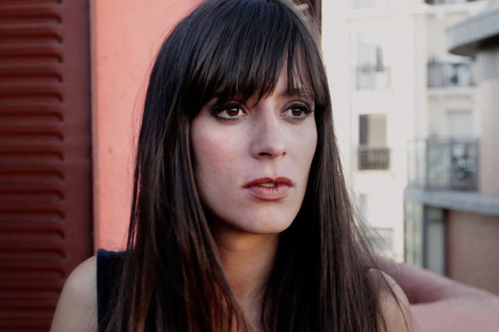
Ángela is a native of Madrid and after studying both journalism and drama, she co-founded the company El Arrabal, and received the Best Actress award in CERTALC for her performance in their production of Arthur Schnitzler’s La Ronde. She crossed paths with Peter Domankiewicz in CinemaRoom, an actors’ studio in Madrid run by the American teacher Chris Geitz and they found they had a very natural performing relationship. They acted together in the play A Little Learning written and directed by Matt Randle, staged in Madrid. Not long after they began work on TEA & SANGRIA, where she not only plays opposite Peter but also helped with the casting process and acted as an informal coach to him during filming. She has also starred in Diamond Flash by Carlos Vemut, whose second film (Magical Girl) just picked up both the Gold and Silver Shell at the San Sebastian Film Festival. She has recently been shooting lead roles in The Stranger by David Gonzalez and The Waiting by Sergio Martinez Villa.

DANIEL ALBALADEJO – JOSE MARIA
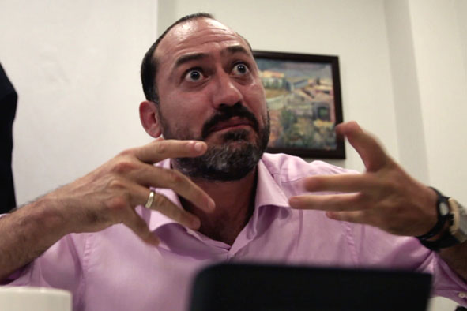
Born in Cartagena (Murcia), Daniel began his studies at ESAD Murcia, graduating in 1994. He studied many disciplines with masters like Norman Taylor (L'Ecole Jacques Lecoq) and Will Keen (Cheek By Jowl). He has worked on more than 30 theatre productions as a member of the National Classical Theatre Company of Spain, National Drama Center and various independent companies. In TV, he was part of the ensemble of Camera Café – one of Spain’s most popular comedy shows, as well as playing in many drama series. He is a familiar face on television lately, playing King Alfonso V of Portugal in the epic TVE series Isabel. He is currently touring Spain in an acclaimed production, playing the lead in Othello. He has appeared in films such as The Incredible Adventures of Pocholo and Mari Borja and Between Heaven and Sea. Having been in consideration for the lead in an earlier film in development by Peter Domankiewicz (not yet made), he signed up for TEA & SANGRIA after reading just one scene featuring his character.

NACHO RUIZ CAPILLAS – EDITOR
It’s probably fair to describe Nacho as Spain’s leading film editor. With more than 70 movies under his belt over the last 20 years he has worked with the majority of Spain’s most important and original cinema talents. At the international level, he’s probably most noted for cutting Alejandro Amenábar’s “The Others” as well as his epic “Agora”. He has a long working relationship with Fernando de León, including the classic “Mondays in the Sun” which firmly established Javier Bardem’s status as a world-class actor. He is also the go-to editor for directors such as Gracia Querejeta (“Hector”), Daniel Sanchez Arevalo (“Family United”) and Juan Carlos Fresnadillo (“Intacto”). He heard about TEA & SANGRIA through a friend, asked to view the first cut that Peter Domankiewicz was working on, and immediately offered to get the film into shape, despite the lack of budget – working on it in the afternoons whilst cutting Spain’s candidate for the Oscars in the morning. He did struggle however, with the jokes in it about Atlético Madrid, his team.

GARRETT WALL – Singer/Songwriter and Music Supervisor
Garrett Wall is a Madrid-based singer-songwriter who relocated from his native Dublin to the Spanish capital in 1999. Since then he has established himself as one of the leading voices in advertising and TV/movie soundtracks. Also a voice-over actor and sometime film actor he relishes the opportunity to combine his two great passions; cinema and music. Apart from his work on TEA & SANGRIA, which marks his first foray into the world of music supervision, he has worked on the soundtracks to "Buried", "The Symmetry of Love" and "Hermanos", and regularly tours and records with his band Track Dogs. His songs were conceived as a commentary upon the action before shooting began and the closing collaboration with Chema Lara “Find My Second Home” was written with TEA & SANGRIA in mind. As plans developed, his band ended up appearing in the film performing and he himself became a minor character in the story.

CAST & CREW
David Peter Domankiewicz
Marisa Angela Boix
Jose Maria Daniel Albaladejo
Ricardo Carlos Pontini
Tamara Agnes Kiraly
Ignacio Jorge Berges
Pichi Xavi Lapuente
Lola Nur Aiza
Francoise Pilar Bastardes
Nuria Ana Rogriguez Calvo
Alejandro Antonio De Matteo
Clare Elea Easton
Pablo Ignacio Ysasi
Daughter of Ricardo Miriam Martin
Mar Oti Manzano

Directed by Peter Domankiewicz
Written by Peter Domankiewicz
Edited by Peter Domankiewicz
Nacho Ruiz Capillas
Art Director Silvia De Valentin
Gerardo Lopez Pouso
Make-up Artist Lina Rodriguez
Production Manager Tatiana Arboleda
First Assistant Directors Tatiana Arboleda
Daniel Matesanz
Sound Assistant Nichel Arenas
Sound Mixer Jose Luis Morales
Principal Photography Francisco Albilares
Hernan D’Arino
Additional photography Julio Cesar Porras
Music Supervisor Garrett Wall
Script Supervisor Judith Dominquez

Top of Form

